**Online Examination Project By Moksha Dhall**

1.Home Page

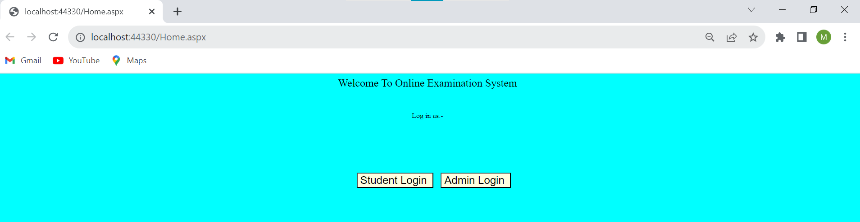

2.Admin Login Page

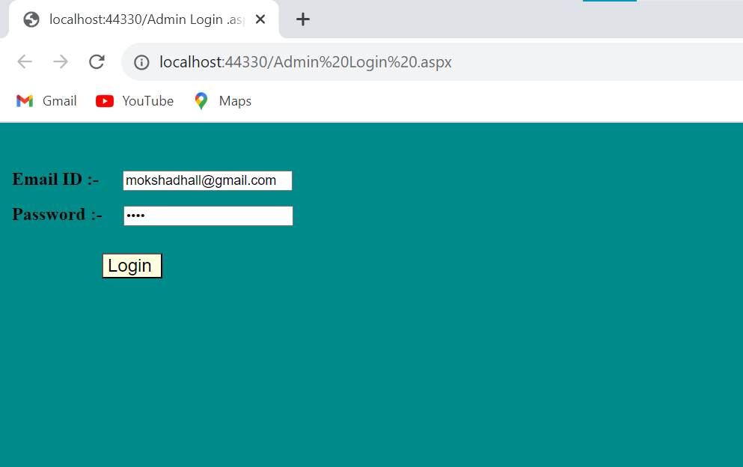

3.Admin Dashboard Page

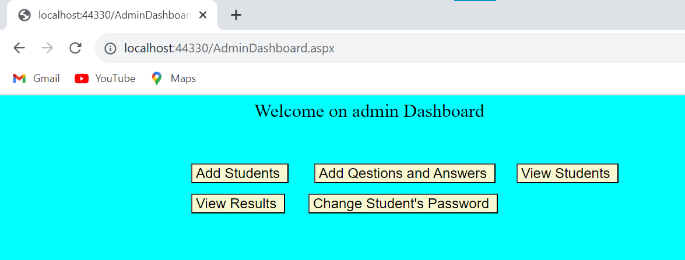

4.Add Students Page

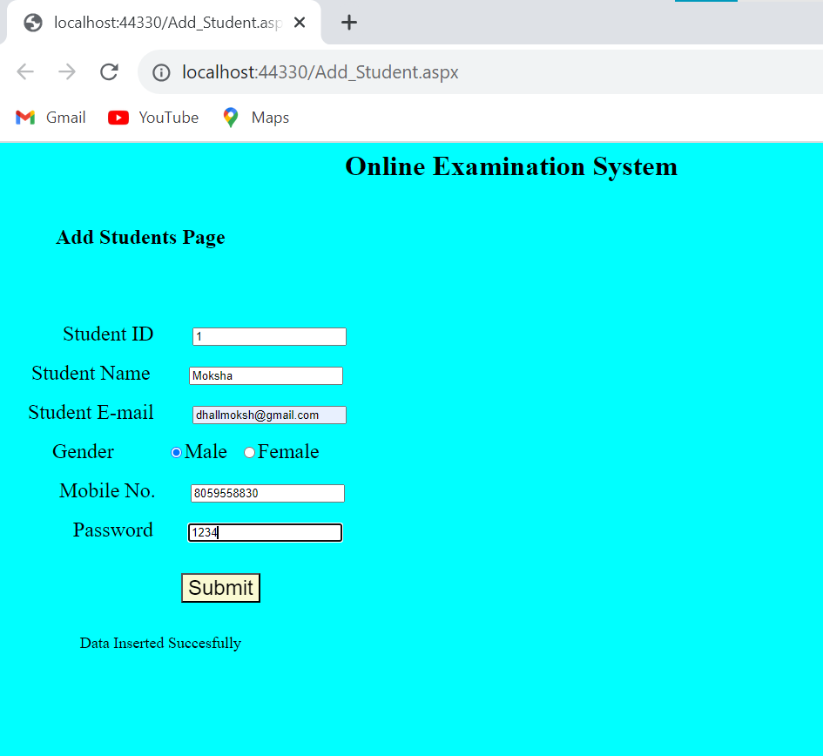

5.Add Questions Page

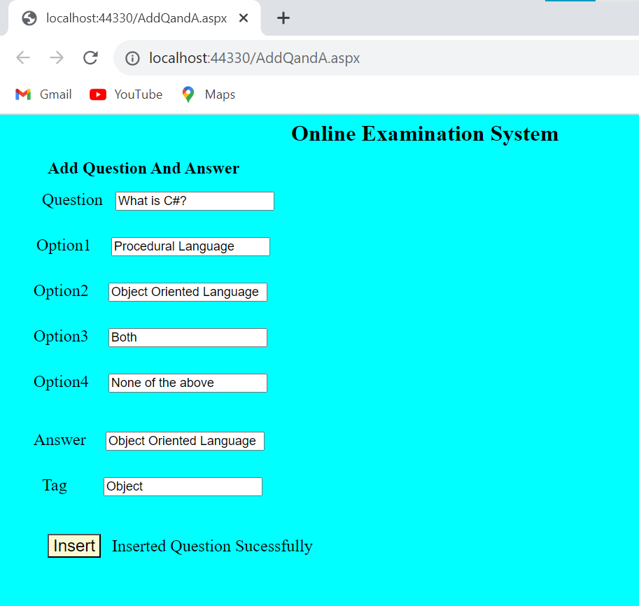

6

7.Change Password

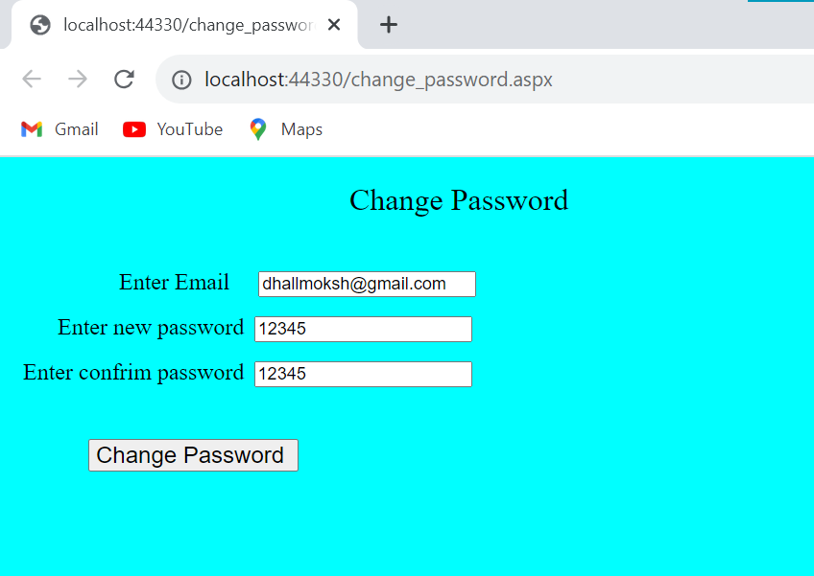

8.Student Login

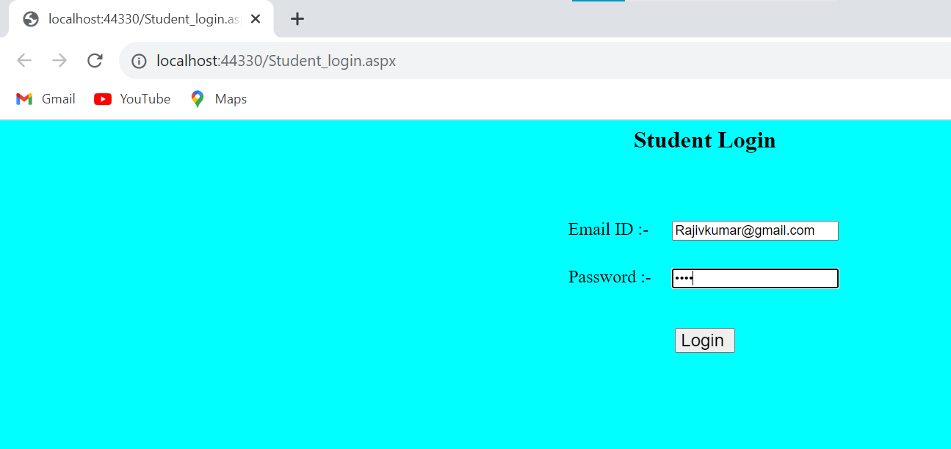

9. Student Dashboard

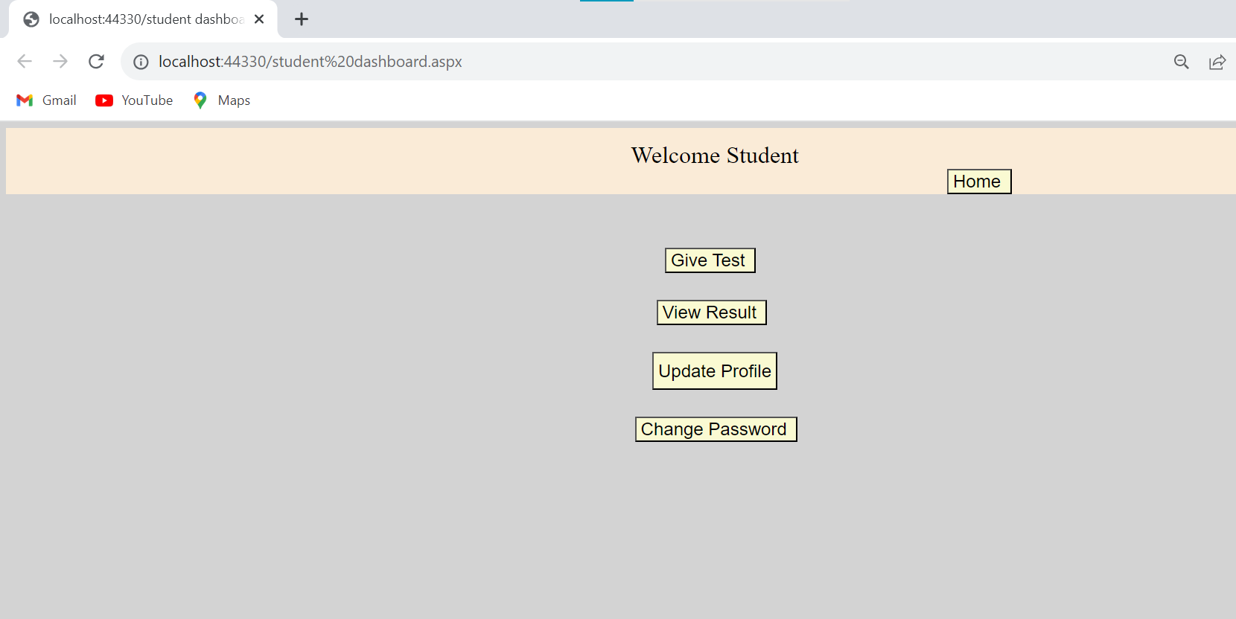

10. Give Test

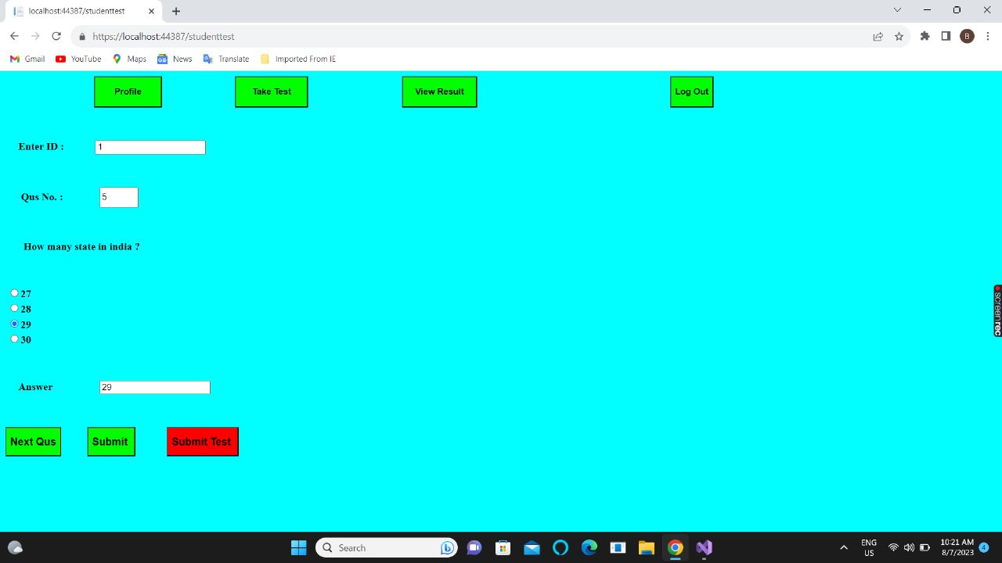

11. View Result

12.Update Profile

13. Change Student Password

